Chapter 1

PROJECT INTRODUCTION

Project Introduction
OVERVIEW OF PROJECT:

This is a website designed in such a way, to keep the service part like hardware information & replacement management, in this website administrator of InfoTech can help Customer to repairing and replacement of their hardware component. The nave user only takes information of different hardware and the solution of hardware related problems through this site. They can not view hardware replacement and as well as editing data of this site.you can download tutorial & videos.
The few characteristics of our project that makes the situation different are:
Savings of Time:
As we know, to repairing and replacing of hardware devices may take long processes and customer not have enough knowledge of hardware devices related problems every time. So to avoid this problem we have to make online hardware replacement and repairing management system where many users can request for their problems simultaneously. That is how the processes will be much faster and easier than they were before and time will be saved.
Reduce Workload:
In the current situation, to manage customers request for their hardware repairing and hardware replace, is much complex. He / She needs to be depended on the operators. But after the application of this project, he / she can get solutions and as well as information more fast for customer
Beneficial to the customer and administrator:
After the application of this project, the processes will take place in a systematic manner. So time duration of each stage will get decreased.
As we know, to repairing and replacing of hardware devices may take long processes and customer not have enough knowledge of hardware devices related problems every time. So to avoid this problem we have to make online hardware replacement and repairing management system where many users can request for their problems simultaneously. That is how the processes will be much faster and easier than they were before and time will be. It is very time consuming process. So by the use of this web application the time can be saved.
But if these ideas are applied then there can be few advantages to the system. Likewise, the processes will be faster and efficient. Workload will also be decreased.
This project will be a real help to the customer and as well as administrator also & help of student. It will be a totally computerized process.
These are some of the advantages of this project which will be useful to the customer and to the administrator of InfoTech directly or indirectly in all the directions like cost, memory, time, interaction etc.

SCOPE OF PROJECT:
Generally in InfoTech began with a long queue and after this application there will also be a long queue but in a different manner and that is, an ease of the things which will make Customer & administrator feel more comfortable that they would not be feeling in the current situation. The main aim of this project will be fulfilled after the relief of Customer & administrator.
At the same time, these offices face many challenges: increasing efficiency by doing more with less.
This project has powerful capabilities that enable the InfoTech’s to improve Customer outcomes and enhance the efficiency, reliability and comforts which are the most required things at present.
It works only on the local Intranet.

PURPOSE OF PROJECT:
We have all heard that knowledge is power. Each project provides knowledge to the learners. The purpose of this project is to provide some functionality such as -
- Transparency,
- Speed,
- Consistency,
- Standardization of requirements
- Cost saving.

And some functionality to the InfoTech’s such as –
- Efficiency,
- Better work environment due to lesser user interface,
- Accountability – Timely completion of work,
- Traceability – Track of pending work.

MODULES OF PROJECT:
A set of such capabilities provided by this project are:
- Masters:
- After logging into the system, Administrator add the information & required data for replacement of hardware but user login system so he/she can take information, problem solution about hardware.
- After that the operator will make Registration.
- Then he / she will show general details like hardware devices related problem.

- InfoTech System Services:
- In this module, different forms are processed.
- At first, an entry for a Registration is accepted.
- All the details of a Customer & Product are filled up by administrator and submit it.
- As well as administrator can find details about hardware product & Customers.
- User He/she take information about hardware devices & problem solution.

Chapter 2

PROJECT PLAN

Project Planning:
PROJECT FLOW:

The main flow of the entire training session can be broken down into the following parts:

- Learning the technology to be used :
This includes an in depth study of the features of ASP.net, php and using MySQL database Toolkit with apache server.
- Developing sample applications :
This includes the usage of ASP.net, php and the user controls (Standard Common Controls, Data Controls, Menu & Toolbar Controls, Add References, Chart Controls) provided by it with the C# as the code-behind language. Also sample applications for viewing, inserting, editing data from a MySQL database were created.
- Analysis & Research into InfoTech system Project :
An intensive study of previous version of InfoTech services web application which made by k.D.Polytechnic students. Lists of most common and likely features were noted down as the initial Requirement Specification document discussed in the next section.
- UML Diagram to specify the System Design :
The use-case diagram, class diagram, activity diagram were prepared to get better picture of what was to be developed.
- Database Design :
Parallel to UML diagram preparation, the entire system’s database design was initiated. A very prompt care was taken to keep the database normalized to avoid redundant data or null fields.
- Preparing the Design Document :
The first stage design document was prepared documenting all the work done before the coding phase begins. A strict adherence to the design document was followed at later stage of development so that our project doesn’t divert from its path to the final goal.
- Building / Coding the Webpage Application :
Modules were divided amongst both of us in the company and the coding was initiated.
- Testing and integrating modules :
Unit testing was carried out by both of us individually along side of our module coding. A later integration testing was performed when the modules were merged into a single project to test the inter-relationships, dependencies and flow from module to module.
- Deploying the project :
In the final stage of project development, the entire project was deployed.
- Preparing the final project document :
All the work done till now was documented in a single project document at which you are looking at.

All Activity Timeline Chart:
Activity  Days | 10 | 20 | 30 | 40 | 50 | 60 | 70 | 80 | 90 | 97
(12 Days)

(25 Days)

(30 Days)

(18 Days)

(12 Days)
System Analysis
System Design
Coding + Unit Testing
Integration testing
Deployment

Chapter 3

REQUIREMENT ANALYSIS

HARDWARE AND SOFTWARE REQUIREMENTS:

Minimum configuration for our webpage application is as below:

  - Hardware:

As our application is a Web application there is no special requirement of the hardware and the usual products that are easily available in the market would serve the purpose. But still the minimum hardware requirements for running “InfoTechServices.com” are listed as below:

- Hardware Requirements:
- Pentium 4 Processor
- 512 MB RAM
- HDD Space
- VGA Monitor or higher resolution
- Barcode Reader
- 10/100 LAN Card (for future implemented)
- Network Establishment

- Software:
The minimum software requirements for developing “InfoTechServices.com” are listed as below:

Software Specification:

- Microsoft Visual studio.NET 2008
- Dreamweaver
- Internet Information Server
- Microsoft word 2007
- WAMP server
- Apache server

- Operating System and System Setting:
- Microsoft Window XP
- Microsoft windows 7 Ultimate.

Chapter 4

SYSTEM DESIGN

DATA FLOW DIAGRAM:
The data flow diagrams are pictorial or graphical representation of the outline of the system study. The data flow diagram covers all the processes and data storage area which takes place during any transaction in the system. The data flow diagrams are functionally divided into context level, First level and Second level data flow diagrams.
Symbols used in DFDs:
  - Process: Here flow of data is transformed. E.g. Charge Calculations, etc.

  - External Entity: A source or destination of data which is external to the system. E.g. Customer etc.

  - A data flow: It is packet of data. It may be in the form of document, letter etc.

  - Data store: Any store data but with no reference to the physical method of storing.

Context Level Diagram

InfoTech Services

Request Request
Customers

Admin

Response Response

1-Level Diagram

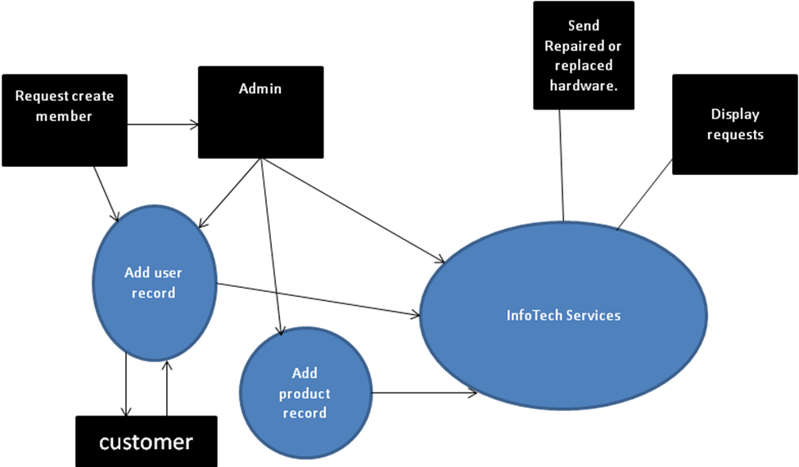

E-R Diagram:
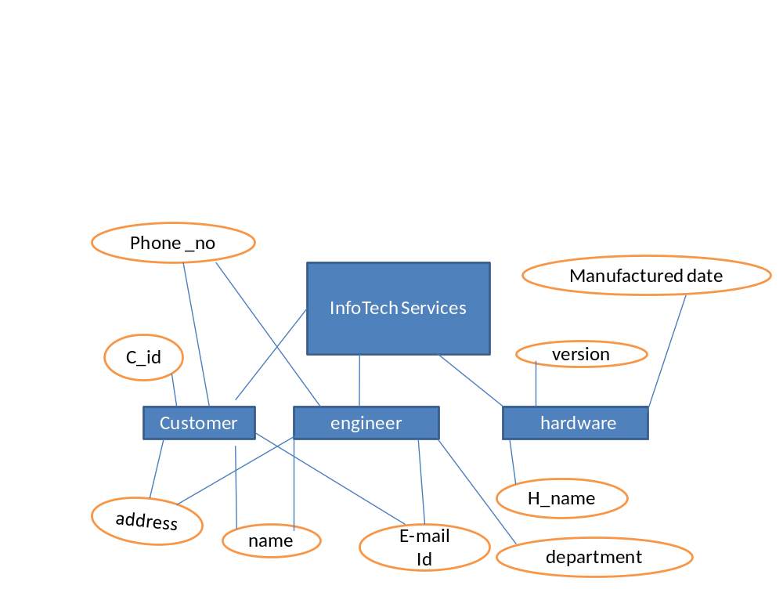

DATA DICTIONARY:
List of Table
Sr no |  | Table Name |  |  | Description
1. |  | order_master |  |  | Add customer details, applied for order hardware.
2. |  | replace_master |  |  | Add customer details, applied for replace hardware.
3. |  | repair_master |  |  | Add customer details, applied for repair hardware.

- Table Name : order_master
Table Description : Add customer details, applied for order hardware. .

Column Name | Data Type | Can Be Null | Description
C_id | Int | Primary key | This field is auto-incremented Primary key
Fname | varchar(50) | Not Null | This field indicates Customer’s first name
Lname | Varchar(50) | Not Null | This field indicates Customer’s last name
Contact no | Int(10) | Not Null | This field indicates contact no.
Email | varchar(50) | Not Null | This field indicates email of Customer
Rdate | varchar(50) | Not Null | Indicates date, when customer requesting for hardware replacing.
Htype | Varchar(50) | Not Null | This field indicates hardwaretype.
Cmpny | Varchar(50) | Not Null | This field indicates hardwarecompany.
Address | varchar(50) | Not Null | This field indicates address of Customer

- Table Name : replace_master
Table Description : Add customer details, applied for replace hardware.
Column Name | Data Type | Can Be Null | Description
C_id | Int | Primary key | This field is auto-incremented Primary key
Fname | varchar(50) | Not Null | This field indicates Customer’s first name
Lname | Varchar(50) | Not Null | This field indicates Customer’s last name
Contact no | Int(10) | Not Null | This field indicates contact no.
Email | varchar(50) | Not Null | This field indicates email of Customer
Rdate | varchar(50) | Not Null | Indicatesdate, when customer requesting for hardware replacing.
Htype | Varchar(50) | Not Null | This field indicates hardwaretype.
Cmpny | Varchar(50) | Not Null | This field indicates hardwarecompany.
Address | varchar(50) | Not Null | This field indicates address of Customer

- Table Name : repair_master
Table Description : Add customer details, applied for repair hardware.
Column Name | Data Type | Can Be Null | Description
C_id | Int | Primary key | This field is auto-incremented Primary key
Fname | varchar(50) | Not Null | This field indicates Customer’s first name
Lname | Varchar(50) | Not Null | This field indicates Customer’s last name
Contact no | Int(10) | Not Null | This field indicates contact no.
Email | varchar(50) | Not Null | This field indicates email of Customer
Rdate | varchar(50) | Not Null | Indicatesdate, when customer requesting for hardware replacing.
Htype | Varchar(50) | Not Null | This field indicates hardwaretype.
Cmpny | Varchar(50) | Not Null | This field indicates hardwarecompany.
Address | varchar(50) | Not Null | This field indicates address of Customer

Chapter 5

USER MANUAL

- HOME
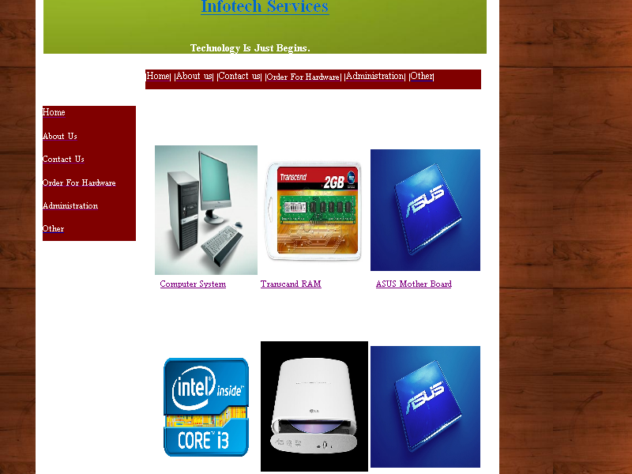

- This page is the main page of this web application. Which help to the overall site to interact by clicking on button. This page is also containing some other hardware information like hardware photo, its configuration, as well as its cost.

- ABOUT US

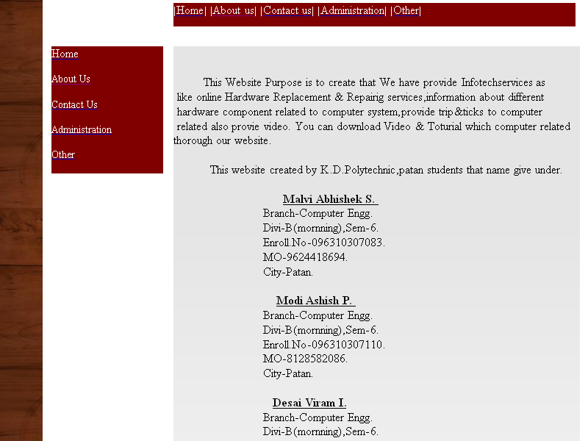

- This button is used to provide some general information about this aplicationdevloper and designer.

- ADMINISTRATION

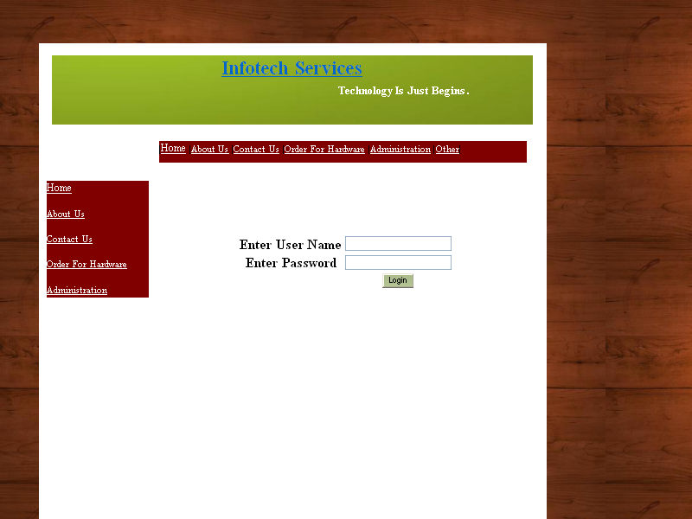

- By clicking on Administration button this website will shows you a web page .by which admin user can connected to the hardware replacement management system’s web application.

- CONTACT US

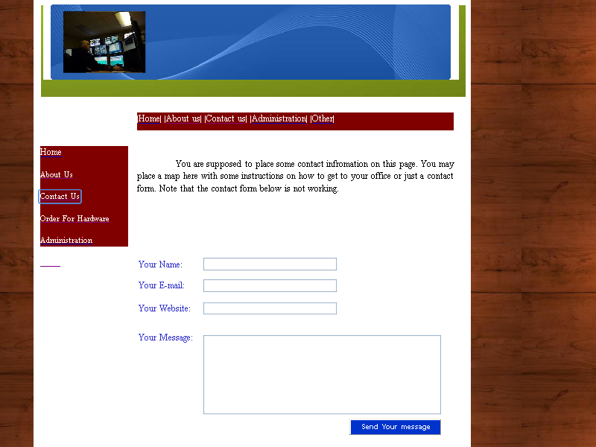

- This button provides a web page to provide information by which Customer can contact to us.

- OTHERS

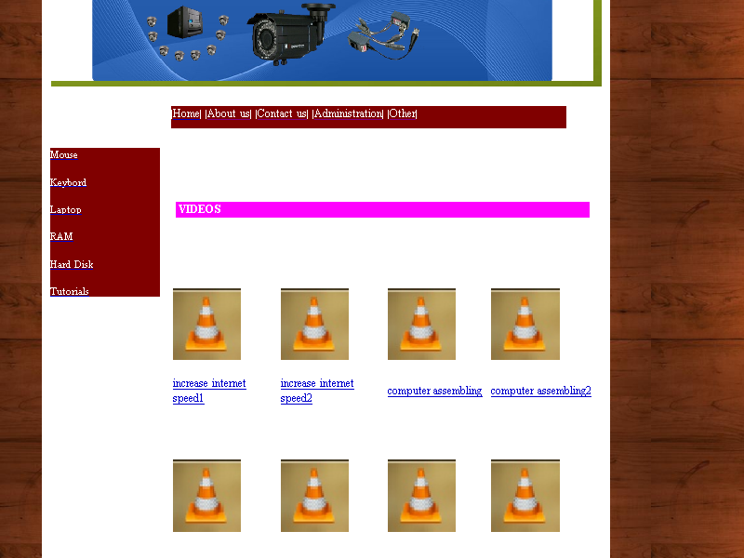

- By clicking on the other button any type of user can show a web page which has a list of common problems of computer of hardware related. It contains videos, tutorials, images related to computer system.

Chapter 6

TESTING

TESTING
The computer society defines testing as follows: “Testing—A verification method that applies a controlled set of conditions and stimuli for the purpose of finding errors. This is the most desirable method of verifying the functional and performance requirements. Test results are documented proof that requirements were met and can be repeated. The resulting data can be reviewed by all concerned for confirmation of capabilities”.

Testing is the critical element in the software process that could be viewed as destructive rather than constructive. It represents the ultimate view of specification design and coding.
System Testing is used experimentally to ensure that the software does not fail, i.e. that it will run according to its specifications. Special test data are input for processing.

Systems testing do not test the software but the test integration of each module in the system. It also tests to find discrepancies between the system and its original objective, current specifications and system documentation.

The system itself may not report this as an error, but the output may show unexpected result.
When a system is developed, it is hope that it performs properly. In practice, however, some error always occurs. The main purpose of testing a system is to find the errors and correct them. A successful test is one which finds an error.

The main objectives of system testing are:
~ To ensure that during operation the system will perform as per specification.
~ To make sure that the system meets user's requirements during the operation.
~ To verify that the controls incorporated in the system function as intended.
~ To see that when correct inputs are fed to the system the outputs are correct.
~ To make sure that during operation, incorrect input, processing and outputs will be detected.

TESTING STRATEGIES:
Black box testing:
Black box testing is conducted at the application interface. It is used when the functional operations of the application are to be tested. Knowing the specified function that the application has been designed to perform, tests were conducted that demonstrated that specific functions are fully operational while at the same time searching for errors. It was used to demonstrate input is properly accepted and output is correctly produced.
White box testing:
White box testing is predicated on close examination of procedural detail. Here the limited numbers of important logical paths are defined, test cases were developed to exercise logical paths and results were evaluated to ensure their validity

TESTING METHODS:
Unit Testing
Module Testing
Sub-system Testing
System Testing
Acceptance Testing

Unit testing:
Unit testing focuses verification effort on modules. The whole system was tested module wise. The module interface was tested to ensure that information properly flows into and out of program unit under test. All the independent paths were exercised to ensure that all statements in module have been executed at least once.
Integration testing:
Integration testing is the phase of software testing in which individual software modules are combined and tested as a group. It follows unit testing and precedes system testing. Integration testing takes as its input modules that have been checked out by unit testing, groups them in larger aggregates, applies tests defined in an Integration test plan to those aggregates, and delivers as its output the integrated system ready for system testing.

Chapter 7

ANNEXURE

ABOUT TOOLS AND TECHNOLOGY:

NET Framework 3.5:
What is .net frame work?
The Microsoft .NET Framework is a software framework that can be installed on computers running Microsoft Windows operating systems. It includes a large library of coded solutions to prevent common programming problems and a virtual machine that manages the execution of programs written specifically for the framework. The .NET Framework is a key Microsoft offering and is intended to be used by most new applications created for the Windows platform.
The framework's Base Class Library provides a large range of features including user interface, data and data access, database connectivity, cryptography, web application development, numeric algorithms, and network communications. The class library is used by programmers, who combine it with their own code to produce applications.
Programs written for the .NET Framework execute in a software environment that manages the program's runtime requirements. Also part of the .NET Framework, this runtime environment is known as the Common Language Runtime (CLR). The CLR provides the appearance of an application virtual machine so that programmers need not consider the capabilities of the specific CPU that will execute the program. The CLR also provides other important services such as security, memory management, and exception handling. The class library and the CLR together constitute the .NET Framework.

Features:
Interoperability
Because interaction between new and older applications is commonly required, the .NET Framework provides means to access functionality that is implemented in programs that execute outside the .NET environment. Access to COM components is provided in the System.Runtime.InteropServices and System.EnterpriseServices namespaces of the framework; access to other functionality is provided using the P/Invoke feature.

Common Runtime Engine
The Common Language Runtime (CLR) is the virtual machine component of the .NET framework. All .NET programs execute under the supervision of the CLR, guaranteeing certain properties and behaviors in the areas of memory management, security, and exception handling.

Language Independence
The .NET Framework introduces a Common Type System, or CTS. The CTS specification defines all possible data types and programming constructs supported by the CLR and how they may or may not interact with each other. Because of this feature, the .NET Framework supports the exchange of instances of types between programs written in any of the .NET languages. This is discussed in more detail in Microsoft .NET Languages.

Base Class Library
The Base Class Library (BCL), part of the Framework Class Library (FCL), is a library of functionality available to all languages using the .NET Framework. The BCL provides classes which encapsulate a number of common functions, including file reading and writing, graphic rendering, database interaction and XML document manipulation.

Simplified Deployment
The .NET framework includes design features and tools that help manage the installation of computer software to ensure that it does not interfere with previously installed software, and that it conforms to security requirements.

Security
The design is meant to address some of the vulnerabilities, such as buffer overflows, that have been exploited by malicious software. Additionally, .NET provides a common security model for all applications.

ASP.NET:
The ASP.NET classes support the development of Web-based applications and Web services. The Windows Forms classes support the development of desktop-based smart client applications. Together, the class libraries provide a common, consistent development interface across all languages supported by the .NET Framework.
ASP.NET web application run on a web server configured with Microsoft Internet Information Services (IIS). However, you do not need to work directly with IIS. You can program IIS facilities using ASP.NET classes, and Visual Studio handles file management tasks such as creating IIS applications when needed and providing ways for you to deploy your web applications to IIS.
ASP.NET provides a unified Web development model that includes the services necessary for you to build enterprise-class Web applications. While ASP.NET is largely syntax compatible with Active Server Pages (ASP), it provides a new programming model and infrastructure that allow you to create a powerful new class of applications. ASP.NET is part of the .NET Framework and allows you to take full advantage of the features of the common language runtime, such as type safety, inheritance, language interoperability, and versioning.

Microsoft Visual Studio 2008:

Microsoft Visual Studio is the main Integrated Development Environment (IDE) from Microsoft. It can be used to develop console and GUI applications along with Windows Forms applications, web sites, web applications, and web services in both native code as well as managed code for all platforms supported by Microsoft Windows, Windows Mobile, .NET Framework, .NET Compact Framework and Microsoft Silver light.
Visual Studio includes a code editor supporting IntelliSense as well as code refactoring. The integrated debugger works both as a source-level debugger and a machine-level debugger. Other built-in tools include a forms designer for building GUI applications, web designer, class designer, and database schema designer. It allows plug-ins to be added that enhance the functionality at almost every level - including adding support for source control systems (like Subversion and Visual SourceSafe) to adding new toolsets like editors and visual designers for domain-specific languages or toolsets for other aspects of the software development lifecycle (like the Team Foundation Server client: Team Explorer).
Visual Studio supports languages by means of language services, which allow any programming language to be supported (to varying degrees) by the code editor and debugger, provided a language-specific service has been authored. Built-in languages include C/C++ (via Visual C++), VB.NET (via Visual Basic .NET), and C# (via Visual C#). Support for other languages such as F#, Python, and Ruby among others has been made available via language services which are to be installed separately. It also supports XML/XSLT, HTML/XHTML, JavaScript and CSS. Language-specific versions of Visual Studio also exist which provide more limited language services to the user. These individual packages are called Microsoft Visual Basic, Visual J#, Visual C#, and Visual C++.
Currently, Visual Studio 2008 and 2005 Professional Editions, along with language-specific versions (Visual Basic, C++, C#, J#) of Visual Studio 2008 are available to students as downloads free of charge via Microsoft's Dream Spark program.

MySQL:
- MySQL is a full-featured relational database management system (RDBMS) that offers a variety of administrative tools to ease the burdens of database development, maintenance and administration. In this article, this is opensource database any can use without chargies.
- This is very usefull and easy acess.You can made dynamic application thorough mysql.You canot use this database in window application.
- Mysql is Enhanced and Inherited version of SQL(Server Query Language) and fully compatible with PHP.So it is easy to develop dynamic .
- Query Analyzer offers a quick and dirty method for performing queries against any of your MySql databases. It's a great way to quickly pull information out of a database in response to a user request, test queries before implementing them in other applications, create/modify stored procedures and execute administrative tasks.
- MySQL Profiler provides a window into the inner workings of your database. You can monitor many different event types and observe database performance in real time. MySQL Profiler allows you to capture and replay system "traces" that log various activities. It's a great tool for optimizing databases with performance issues or troubleshooting particular problems.
.

Bibliography:-
- www.google.com
- www.project1000.com
- C# complete refrence2.0 :-By Herbly Shedit

